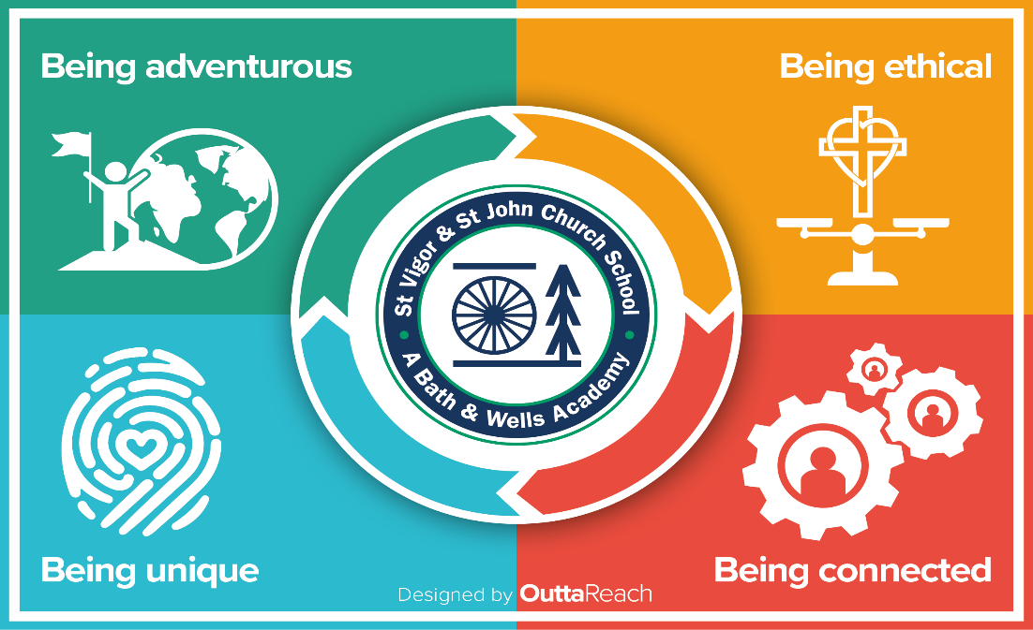

Learning Outside The Classroom
Policy/School approach
First approved: November 2022

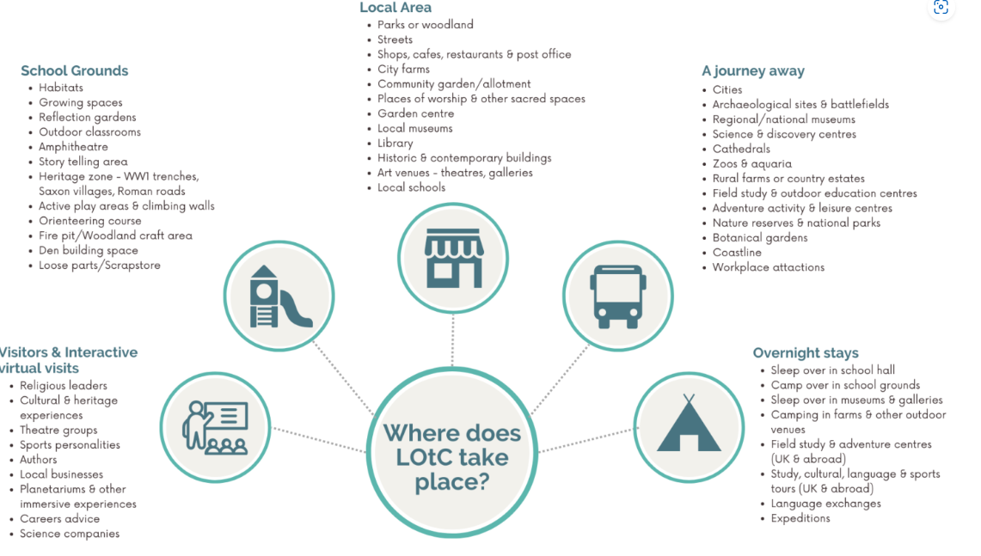

We have used an evidence-based approach to this policy:
Leadership for embedding outdoor learning within the primary curriculum
Purpose:
SVSJ is committed to providing purposeful, enriching experiences that go ‘beyond’ the classroom. The purpose of this document is to recognise the importance of learning outside the traditional classroom environment. It ensures that pupils engage with educational opportunities beyond the classroom in a safe, effective, and structured manner. Learning outside of the classroom fosters real-world connections, personal growth, and supports the development of various skills, including critical thinking, teamwork, and problem-solving.
Scope:
This document applies to all school-organised, extracurricular, and other learning activities that occur outside the classroom setting, including but not limited to field trips, outdoor classrooms, educational visits, virtual learning experiences, educational travel and residential visits and opportunities.
1. Learning Objectives and Goals
All learning outside of the classroom should have clear, measurable objectives that align with the school’s curriculum and educational goals. Teachers and administrators will ensure the following:
- The activity or program directly supports academic learning.
- Activities are designed to foster collaboration, creativity, and critical thinking.
- Students will develop skills that are transferable to both academic and real-world situations.
2. Supervision and Safety
Student safety is the highest priority during any off-campus or external activity. The following procedures will be observed:
- Supervision:
  - All off-site activities must have adequate adult supervision based on the number of students participating and their age group. The student-to-adult ratio will be determined by the nature of the activity and the appropriate risk assessment
  - Teachers and staff leading the activity will be trained in emergency procedures, first aid and risk assessments.

- Transportation:
  - Transportation to and from activities must be arranged through safe, authorised means. As part of our commitment to LOTC the school owns and operates a minibus. The minibus policy is followed throughout and applies.
- Emergency Preparedness:
  - A detailed plan for emergency situations will be provided
  - Parents/guardians will be notified of the location and schedule of activities in advance
3. Parent/Guardian Consent
- Written Consent:
As part of our commitment to LOTC, the school-parent agreement upon admission includes consent for all outdoor activities. SVSJ adheres to the Local Authority guidance surrounding outdoor visits. EECLive is used for local authority when appropriate.
- Communication:
Parents/guardians will be informed in advance of the educational purpose, schedule, costs, and any other relevant details for each activity. Regular updates will be provided in case of changes or cancellations.

4. Equity and Accessibility
The school is committed to ensuring all students have access to learning outside of the classroom. To promote equity:
- Financial assistance or alternative arrangements will be provided to ensure no student is excluded from an activity due to economic constraints. There is no charge for visits that use the school minibus.
- Activities will be selected with consideration to the diverse needs of all students, including those with disabilities. Accessible transportation and venue accommodations will be prioritised.

5. Respectful and Responsible Behaviour
Students are expected to represent the school positively while participating in any off-campus activity. This includes:
- Adhering to the school's Code of Conduct and behavioral expectations at all times.
- Demonstrating respect for the local environment, cultural sites, and communities visited.
- Cooperating with teachers, chaperones, and peers to ensure a positive learning experience.
Violations of the behavior expectations will result in disciplinary action, which may include exclusion from future off-campus activities.

6. Environmental and Sustainability Awareness
When engaging in learning outside of the classroom, all activities will aim to promote environmental consciousness. The school encourages:
- Eco-friendly practices such as reducing waste, recycling, and conserving energy during activities.
- Raising awareness about the importance of sustainability in students’ everyday lives.

7. Evaluation and Feedback
To ensure that learning outside of the classroom meets its intended educational goals, the following practices will be in place:
- Teacher Evaluation:
Teachers will assess the success of each activity in relation to its learning objectives and gather feedback from students and parents.
- Student Reflection:
After participating in any off-campus activity, students are encouraged to reflect on their experiences, learning outcomes, and how the activity impacted their academic growth.
- Feedback Collection:
Feedback forms will be distributed to students and parents to improve the planning and execution of future activities.

Implementation and Review
This policy will be reviewed annually by school leadership to ensure its relevance and effectiveness. Teachers, staff, and pupils will be consulted for feedback, and any necessary adjustments will be made to improve the quality and safety of learning experiences outside the classroom.

By adhering to this approach, the school strives to create a diverse, inclusive, and engaging learning environment that extends beyond the traditional classroom and contributes to the development of well-rounded, curious, and responsible learners.

